IMPROVING MATHEMATICS CRITICAL THINKING ABILITY AND SELF REGULATED LEARNING OF HIGH SCHOOL METHOD THROUGH IMPROVE STUDENTS

Dinar Andriyani¹, Citra Megiana Pertiwi²

IKIP Siliwangi Bandung
¹dinarandriyani000@gmail.com, ²citra.megianapertiwi@gmail.com

Received: XXXXX X, XXXX; Accepted: XXXXX X, XXXX

Abstract

The low critical thinking skills and self-regulated learning in the field are the backgrounds for this research. This study aims to examine the improvement of mathematical critical thinking skills and self- regulated learning using the IMPROVE method and by using ordinary learning. The research method used was an experimental method with a pretest-posttest group research design involving two groups and randomized class sampling. The population is all high school students in Purwakarta Regency. All high schools in Purwakarta were randomly selected, SMAN 1 Maniis was selected, the sample was randomly selected by two classes, class XI Mia 2 as the control class and class XI Mia 1 as the experimental class. Data collection in this study was in the form of tests and non-tests, then the data on the scores of students' mathematical critical thinking skills and learning independence were analyzed using descriptive and inferential statistics using the two-difference test means. Based on the results of the study, both from the results of data analysis and hypothesis testing, the authors conclude that the achievement and improvement of mathematical critical thinking skills and self- regulated learning students whose learning using the IMPROVE method are better than those using ordinary learning.

Keywords: Mathematical critical thinking skills, self-regulated learning, IMPROVE method

Abstrak

Rendahnya kemampuan berpikir kritis dan kemandirian belajar di lapangan yang melatar belakangi penelitian ini. Penelitian ini bertujuan menelaah peningkatan kemampuan berpikir kritis matematis dan kemandirian belajar siswa dengan menggunakan metode IMPROVE dan yang menggunakan pembelajaran biasa. Metode penelitian yang digunakan adalah metode eksperimen dengan desain penelitian kelompok pretes-postes yang melibatkan dua kelompok dan pengambilan sampel dilakukan secara acak kelas. Populasinya adalah seluruh siswa SMA di Kabupaten Purwakarta. Seluruh SMA di Kabupaten Purwakarta dipilih secara acak, terpilih SMAN 1 Maniis, sampel dipilih dua kelas secara acak kelas dimana kelas XI Mia 2 sebagai kelas kontrol dan kelas XI Mia 1 sebagai kelas eksperimen. Pengumpulan data dalam penelitian ini berupa tes dan non tes, kemudian data skor kemampuan berpikir kritis matematis dan kemandirian belajar siswa tersebut dianalisis dengan statistik deskriptif dan inferensial dengan menggunakan uji perbedaan dua rata-rata. Berdasarkan hasil penelitian, baik dari hasil analisis data maupun pengujian hipotesis, maka penulis menyimpulkan bahwa pencapaian dan peningkatan kemampuan berpikir kritis matematis dan kemandirian belajar siswa yang pembelajarannya menggunakan metode IMPROVE lebih baik daripada yang menggunakan pembelajaran biasa.

Kata Kunci: Kemampuan berpikir kritis matematik, kemandirian belajar, metode IMPROVE

How to Cite: Andriyani, D. (2020). Improving Mathematics Critical Thinking Ability and Self Regulated Learning Of High School Method Through IMPROVE Students. JIML, X (X), XX-XX.

INTRODUCTION

Mathematical critical thinking skills in mathematics education are important abilities that need to be trained in students because they can train how to think and reason in concluding, as well as develop problem-solving abilities. According to Ryder (Tawil & Liliasari, 2013) states that critical thinking skills are very important in carrying out daily activities, a capable person who will have the ability to develop. Enis (Susilawati, 2012) defines that the ability to think critically is a thought process to make reasonable decisions about what to believe or do. However, the fact is that students' mathematical critical thinking skills are low, this was stated by Setyaningsih, Agoestanto, and Kurniasih (2014) who stated that in learning mathematics in the classroom, many students have not been able to develop their critical thinking skills, this is because the student's critical thinking process rarely becomes the teacher's spotlight at the time. It is assumed ongoing mathematics learning is because teachers rarely give problems that encourage students to develop their critical thinking skills. this causes the low ability of students to think critically in mathematics according to Lestari (2014) that, the ability to connect and think critically in mathematics students is not as expected. One of the factors that cause this problem is learning that does not provide flexibility for students to optimally empower the potential of the brain, where learning generally emphasizes the use of left-brain functions, meanwhile, mathematical connection and critical thinking skills need to be supported by right-brain movement.

In addition to critical thinking skills, independent learning must also be applied to students. According to Hargis and Karlin (Sumarmo, 2015) defines self-regulated learning as an effort to deepen and manipulate associative networks in a particular field, and monitor and improve the deepening process that Regarding, the reality in the field states that students' learning independence is low, this is supported by the opinion of Jumaisyaroh, Napitupulu and Hasratuddin (2014) who say that independent learning has not been socialized and developed among students, they think that teachers are the only source of knowledge, causing students to have dependence with other people, especially on teachers.

Therefore, critical thinking skills and student learning independence must be improved. Sumarmo (2016) states that indicators of mathematical critical thinking skills are: 1). Check the correctness of arguments, statements, and solution processes; 2). Compile a statement accompanied by reasons; 3). Identifying relevant and irrelevant data of a mathematical problem; 4). Identify assumptions; 5). Compose answers or solve math problems with reasons. Meanwhile, based on the opinion of experts Butler, Carno and Randi, Hargis, Kerlin, Paris and Winograd, Schunk and Zimmerman, Wongsri, Cantwell, and Archer (Sumarmo, 2015) indicators of independent learning include:/ 1). Initiative and intrinsic learning motivation; 2). The habit of diagnosing learning needs; 3). Setting learning goals or targets; 4). Monitor, organize, and control learning; 5). View adversity as a challenge; 6). Make use of and search for relevant sources; 7). Choosing, implementing learning strategies; 8). Evaluating learning processes and outcomes; 9). Self-ability.

In overcoming the problem of low ability to think mathematically and independent learning, it is necessary to develop learning methods and find alternatives that can improve mathematics learning. One of the alternatives that can be selected is the IMPROVE method, this method is based on the theory of cognition and social metacognition for heterogeneous classes. In learning with the IMPROVE method, students are positioned to learn in groups to solve existing problems, because the group consists of heterogeneous students, so this can highlight group interactions such as questions and answers, exchange of opinions, and debates between students. Therefore, the use of this method is expected to improve mathematical critical thinking skills and students' learning independence.

METHOD

This research is experimental because the sampling is random, besides that there a special treatment in the experimental class, namely learning using the IMPROVE method while in the control class using ordinary learning. At the beginning and end of learning, both classes were given a test with the same instrument so that the research design was a pretest-posttest control group design. The population in this study was as straight as high school students in Purwakarta Regency. All high schools in Purwakarta were randomly selected, SMAN 1 Maniis was selected, the sample was randomly selected by two classes, class XI Mia 2 as the control class and class XI Mia 1 as the experimental class. Analysis of data from the test results of mathematical critical thinking skills and independent learning is by comparing the pretest and posttest scores for gain score data using the test if the data is normally distributed and if homogeneous, if the data is not normally distributed then the Mann Whitney test is carried out. The test criterion for the test for the difference between the two means is that if the significance is more than 0.05 then Ho is accepted.

RESULTS AND DISCUSSION

Results

The recapitulation of the research results of the mathematical critical thinking skills and self -regulated learning of students between learning using the IMPROVE method and regular learning is presented in the following table:

Figure .1 Table of Average Critical Thinking Ability and self-regulated learning
Based on the recapitulation of the test results of students' mathematical critical thinking skills, it can be seen in Figure 1 that the mean pretest (initial ability) scores of students are not much different, with the experimental class score of 0.87 and the control class 0.53, after being given different learning where the class The experiment using the IMPROVE method increased by an average of 20.8, while for the control class who was given regular learning to 15.7, from the average value it was seen that the experimental class was better than the control class seen from the average value, then for the gain scores of the experimental class and the control class, respectively 0.46 and 0.38, it can be seen that the experimental class has better average gain values ​​than the control class. As for the independent learning, it can be seen that the pretest of the control class and the experimental class is not much different, then for the post-test, the experimental class is better or the average value is higher than the control class, the same thing with the gain of the experimental class the average value is higher than the class. control. After that, a statistical test was carried out to see the increase in mathematical critical thinking skills and students' learning independence, namely using the two-difference test. From the results of the statistical test, the gain score for the ability to think critically in mathematics, the two mean differences test are obtained as follows:

Tabel 1. Test Results of the Difference between the Two Average Mathematical Critical Thinking Abilities
 |  |  | Gain Value of Mathematical Critical Thinking Ability
Mann-Whitney U |  |  | 241,000
Monte Carlo sig. (2-tailed) | Sig. 95% Confidence Interval | Lower Bound Upper Bound | ,001^{b}  ,000  ,002
Monte Carlo sig. (1-tailed) | Sig. 95% Confidence Interval | Lower Bound Upper Bound | ,001^{b}  ,000  ,001

Based on the data in Table 1. it can be seen that Sig. (1-tailed) is 0.001, this value meets the Sig. (1-tailed) ≤ 0.05 then H_0 is rejected, which means that the increase in students' mathematical critical thinking skills is significantly better than those using the IMPROVE method that is better than those using ordinary learning.
In addition to the analysis of mathematical critical thinking skills, the data on student learning independence will also be analyzed, after which the results of the two-difference test on the average student learning independence will be discussed.
Table 2. Test the Difference between the Two Average Data on Self Regulated Learning
 |  |  | Self Regulated Learning Gain Value
Mann-Whitney U |  |  | 159,500
Monte Carlo sig. (2-tailed) | Sig. 95% Confidence Interval | Lower Bound Upper Bound | ,000^{b}  ,000  ,000
Monte Carlo sig. (1-tailed) | Sig. 95% Confidence Interval | Lower Bound Upper Bound | ,000^{b}  ,000  ,000

Based on Table 2, the results of the statistical analysis of the gain of student learning independence. Judging from the results of the two mean difference test with the Mann-Whitney test with sig (1 tailed) 0,000, which means we can conclude that the independent learning mathematics of students whose learning uses the IMPROVE method is better than students whose learning uses ordinary learning.

Learning Overview with the IMPROVE Approach

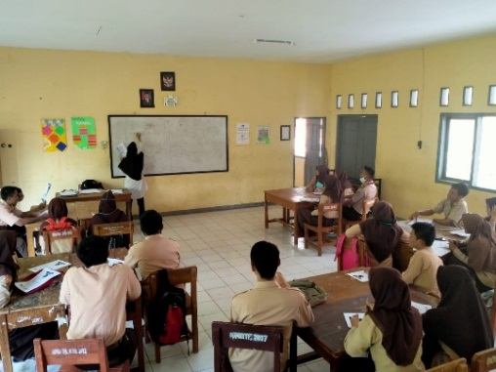
Implementation of learning uses the IMPROVE approach with learning stages carried out in sequence. Before learning, students are grouped heterogeneously. Then given student worksheets. There are several learning steps in the IMPROVE method including:
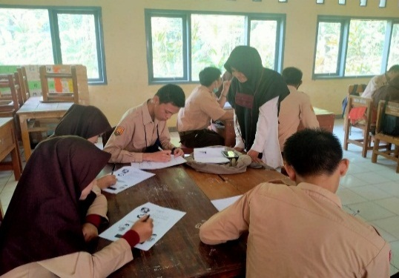

Figure .2 Introducing the new concept Figure .3 Metacognitive Questioning Questioning
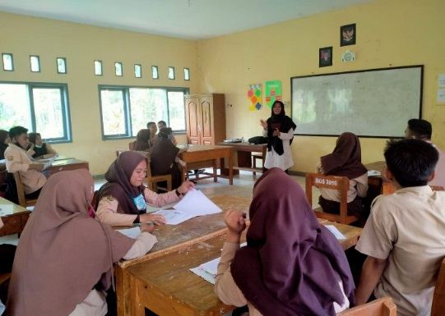
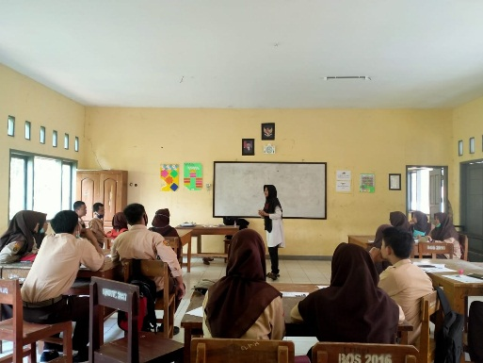

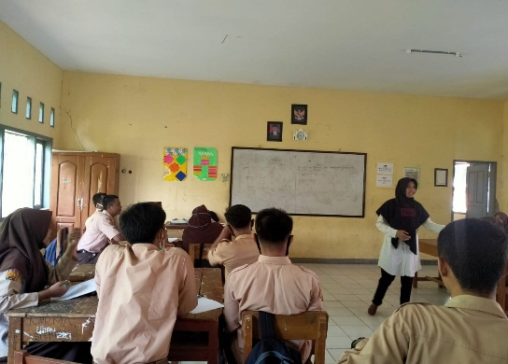
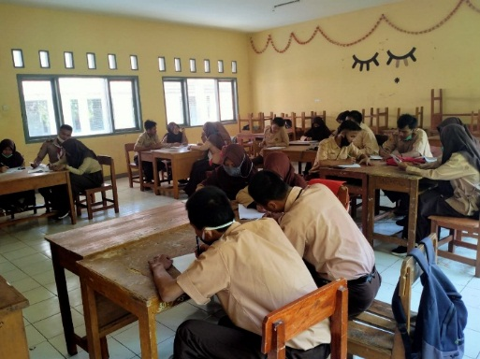
Figure .4 Practicing Figure .5 Reviewing

Figure .6 Obtaining Masteri Figure .7 Verification

In the implementation of learning using the IMPROVE method students are actively involved in working on learning material, this is because in the IMPROVE learning stage many students are trained in working on math problems which results the students being trained in their ability in learning mathematics.

Discussion

The research was conducted in one of the high schools in Purwakarta, namely SMAN 1 Maniis and aims to see the extent to which the improvement of mathematical critical thinking skills and student learning independence after learning in the experimental class and students in the control class using different learning. In the experimental class, the learning uses the IMPROVE method, and in the control, the class uses ordinary learning. Based on data regarding the pretest score between the experimental class and the control class. The average of the two. classes there is no significant difference in the students' initial mathematical critical thinking ability between the experimental class and the control class. Furthermore, the two groups were given different treatments, the experimental group was given learning using the IMPROVE method while the control class was given regular learning.

Also, to see the increase in students' mathematical critical thinking skills before and after being given treatment, again test was held, to see or prove that the mathematical critical thinking skills of students whose learners used the IMPROVE method were better than those using ordinary learning. It can be seen from the two average difference test on the gain that we have analyzed there shows that sig is 0.001, this means that H0 is rejected, it can be concluded that the mathematical critical thinking skills of students whose learners use the IMPROVE method are better than those who use ordinary learning. This is by the opinion of Ansori (2014) that the IMPROVE method is a method designed to help students develop mathematical skills optimally. Then to see the increase in student learning independence we see the significance of the two mean difference tests using the Mann Whitey test. It appears that the significance is 0.00 in other words, the learning independence of students whose learning uses the IMPROVE method is better than those using ordinary learning.

The steps for the IMPROVE method include 1). Introducing the new concept; 2). Metacognitive Questioning; 3). Practicing; 4). Reviewing; 5). Obtaining Mastery; 6). Verification; 7). Enrichment and Remedial. In the first stage, students are given a problem to find out the initial concept of starting learning, students can develop the knowledge they have to find their concept of the material being studied/ after those students are given metacognitive questions then each student exercises the questions given in the student's next step LKS and the teacher discussed the difficulties the students faced during the learning process, then the students were given a test to find out whether the learning objectives had been achieved or not after the test was held, students were told which ones had mastered which material had not mastered, those who had mastered were given enrichment and those that had not been given remedial.

The advantage of the IMPROVE method is that students can find mathematical material concepts independently according to Liberna (2015) arguing that the IMPROVE method is a learning method that encourages students to find out for themselves a learning concept, besides that in general students are actively involved in learning than in groups of students become free exploring the ideas in their thinking, in doing exercises students seem to interact well, besides learning using the IMPROVE method trains students in doing question exercises to better master the given material. However, there are also some disadvantages of this method, namely that it takes a long time because the students' abilities are different so that in solving the problems given, there is a need for special guidance by the teacher, not all students have the ability to understand and record the information given orally.

CONCLUSION

Based on data analysis and research results, several conclusions can be made including:
1. Increased mathematical critical thinking skills of students whose learning using the IMPROVE method is significantly better than those who use ordinary learning
2. Increased self-regulated learning of students whose learning using the IMPROVE method is significantly better than those using ordinary learning
3. Learning using the IMPROVE method has advantages including improving student performance in the learning process and training students in working on various variations of math problems

ACKNOWLEDGMENTS

In this study, the authors thank all those who have helped carry out the research process, at the SMAN 1 Maniis school who have given permission and to all students who participated in the data collection process as well as colleagues who helped the research.

REFERENCES

Tawil dan Liliasari. (2013). Berpikir Kompleks dan Implementasinya dalam Pembelajaran IPA. Makasar: Badan Penerbit UMN.
Susilawati, W. (2012). Belajar dan pembelajaran Matematika. Bandung: CV Insan Mandiri.
Setyaningsih, T. D., Agoestanto, A dan Kurniasih, A. W. (2014). Identifikasi Tahap Berpikir Kritis Siswa Menggunakan PBL dalam Tugas Pengajuan Masalah Matematika. Jurnal Kreano. 5(2): 180-187.
Lestari, K. E. (2014). Implementasi Brain-Based Learning untuk Meningkatkan Kemampuan Koneksi dan Kemampuan Berpikir Kritis serta Motivasi Belajar Siswa SMP. Jurnal Pendidikan UNISKA. 2(1), 36-46.
Sumarmo, U. (2016). Penilaian Terhadap Nilai, Karakter, Budaya dan Asfek Afektif lain serta Pelaksanaan Pembelajaran Matematika. Tersedia di: utari-sumarmo@dosen.stkipsilingawi.ac.id. Di akses (20 Februari 2016).
Sumarmo, U. (2015). Kumpulan Makalah dan Disposisi Matematik serta Pembelajarannya. Bandung: FPMIPA UPI.
Jumaisyaroh, T., Napitupulu, E. E. dan Hasratuddin, H. (2014). Meningkatkan Kemampuan Berpikir Kritis Matematis dan Kemandirian Belajar Siswa SMP melalui Pembelajaran Berbasis Masalah. Jurnal Kreano. 5(2):157-169.
Ansori, H. (2014). Pengaruh Metode Improve terhadap Kemampuan Pemecahan Masalah Siswa pada Konsep Bangun Ruang di Kelas VIII SMP. Edu-Mat Jurnal Pendidikan Matematika. 2(3):279-286
Liberna, H. (2015). Meningkatkan Kemampuan Berpikir Kritis Matematis Siswa melalui Penggunaan Metode Improve pada Materi Sistem Persamaan Linear Dua Variabel. Jurnal Formatif. 2(3):190-197.

