ENGLISH ENTREPRENEURSHIP
AS A COURSE TO EMPOWER STUDENTS’ LIFE SKILL
DURING COVID-19 PANDEMIC ERA

Rasi Yugafiati¹

¹ IKIP Siliwangi
¹ tanya.rasiyugafiati@ikipsiliwangi.ac.id

Abstract

Entrepreneurship education is increasingly popular, as policymakers recognize the necessity for campus graduates to be hired. Not everyone has the ability to work as a civil servant. As a result, it is critical to educate skills such as entrepreneurship so that students have no trouble finding work after graduation. The purpose of this study is to determine the teaching of entrepreneurship in the English education department during the COVID-19 pandemic. This research also explores insights about empowering students' skills in earning income through social media. The key data studied in this qualitative descriptive study is the development of student skills in selling goods or services before and after taking an entrepreneurship course. Thirty-six students from the sixth semester of English Education at IKIP Siliwangi participated in this study. The information was gathered by observation, questionnaire, and interview. The majority of the participants (94 percent) agreed that they gained life skills for market communication after taking the entrepreneurship course. Furthermore, 83 percent of students who currently operate an online store reported that their revenue has greatly grown. In conclusion, an entrepreneurship course benefits students by providing them with the option to achieve financial independence even amid the covid-19 pandemic. That benefit hopefully will be very useful in their real life situation.

Keywords: Entrepreneurship, COVID-19 pandemic, English Education

INTRODUCTION

In addition to being skilled in English, university students are expected to acquire life skills. There are a variety of social media platforms that students can utilize to sell their products and services. The difficulty that arises is the likelihood that students may not have much entrepreneurship experience. They require lecturers to serve as role models. Although students can still learn online, ideas and concepts regarding entrepreneurship should be communicated to them.

English Entrepreneurship Course

For a successful career, it's just as crucial to have an entrepreneurial mindset as it is to speak English fluently (Özdemir, 2015). Students are able to practice and demonstrate their English language abilities while applying the content of their business and management courses to the tasks they were given (Crompton & Head, 2003). According to course evaluations, the entrepreneurship topic is both stimulating and relevant to the students' future jobs (Crompton & Head, 2003). Better and more advanced reading abilities, more confidence, cognitive stimulation, increased prospects in college or employment, and a broader vision of the world are just a few of the benefits (Dinçay, 2011). Many of the benefits of entrepreneurship in education have been discussed in this report, including its ability to stimulate deep learning and instill engagement, joy, motivation, confidence, and a sense of relevance in students, as well as its stated and to some extent evidenced effects on job creation, economic success, renewal, and innovation for individuals, organizations, and society as a whole (Lackéus, 2015).

Entrepreneurship through Social Media

The excitement and the headlines come from high-tech. It instills in the community a sense of entrepreneurship and innovation, as well as a willingness to embrace them (Drucker, 1984). Entrepreneurs can use social media to manage and communicate efficiently on how to develop content and information, as well as how to publish it on social networks in a way that attracts people's attention (Tosifyan & Tosifyan, 2017). Entrepreneurs should use various social networking sites to create relationships with their existing and new clients as social media becomes a vital part of people's personal and business lives throughout the world (Turan & Kara, 2018).

Consumers in today's world assess a company's internet presence before making a decision, and marketers are increasingly depending on social media, which involves relatively little work. (Sajane & Gaikwad, 2022). Social media is a new phenomenon that has changed the way businesses operate (Jagongo & Kinyua, 2013). Entrepreneurs may learn more about their consumers' attitudes and behaviors by using social media, and they can potentially give real-time solutions to their problems based on client feedback (Turan & Kara, 2018). Because the number of individuals using social media is always increasing, entrepreneurs may utilize it to sell their products and services to a wider audience (Azhar & Akhtar, 2020).

It has also aided businesses in increasing their worthiness, cultivating strategic partnerships, and increasing contact with customers and suppliers (Jagongo & Kinyua, 2013). Through visibility, timely feedback, and improved customer interactions, such marketing and customer-focused initiatives will strengthen entrepreneurs' brand equity (Turan & Kara, 2018). It may assist companies in lowering costs and increasing sales, as well as creating a brand image and connecting with their customers on a personal level (Azhar & Akhtar, 2020). Because there is a considerable beneficial association between PR and communication outcomes, entrepreneurs should expand the function of social media PR within their start-up (Pakura & Rudeloff, 2020).

Social media marketing is one of numerous marketing strategies that uses social media, which is used by the majority of people nowadays, to adverti se or promote a product, service, brand, or problem (Wardana, 2018). It is critical for business owners and marketers to understand how social media works as a communication and marketing tool, and how they can significantly grow their businesses (Jagongo & Kinyua, 2013). The data analysis revealed that there is sufficient evidence that social media is being used for business; for example, the frequency of social media usage has strong links to users' willingness to buy products or conduct business in that venue; young people, such as college students, are more likely to use social media for business than those with higher levels of education who may already have permanent jobs; and young people, such as college students, are more likely to use social media for business than those with higher levels of education who may already have permanent jobs (Simangunsong & Handoko, 2020). Social media plays a vital role in identifying brands to customers, is generally favorably accepted by customers, and can be a low-cost market for achieving the company's and organization's objectives (Ahmadinejad & Asli, 2017).

METHOD

This research takes a qualitative approach, which is thought to be the right way to approach the research questions. In this case study, the researcher tries to submit a systemic collection of information about a person and group in a social setting (Alwasilah, 2010; Silverman, 2015) in order to gain meaningful insight into determining the teaching of entrepreneurship in the English education department during the COVID-19 pandemic.

RESULTS AND DISCUSSION

Results

This result is divided into three parts; learning situation about English Entrepreneurship during Covid-19 Pandemic Era, students’ responses about the tasks, and students’ life skill in selling products after learning English Entrepreneurship.

Learning Situation
In one semester, students can earn 16 credits by studying English Entrepreneurship. Because the lecture was only in its second meeting when this research was released, it was still ongoing. However, many things could be learned from those two initial meetings.

During the first meeting, the researcher inquired about the students' interest in entrepreneurship in the aftermath of the Covid 19 pandemic. Only a few students mentioned that they had an online store. The rest of the time, the students went about their normal lives as students and teenagers.

Following that, the researcher discussed the need of having a secondary source of income during the epidemic. The students were taught that during the COVID-19 pandemic, an increasing number of people were using social media. As a result, using social media for business was a fantastic opportunity. They could do business through paid or organic channels. They realized that paid channels like Facebook Ads and Tiktok Ads made it simple for students to manage their energy and time. If their finances were still limited, they should pursue entrepreneurship through organic channel. The channel was recognized for its WhatsApp media sales.

Students were given instructions on how to market strategies by optimizing the use of the WhatsApp application during the meeting. The first step was to tidy up the database. The term "database" refered to a collection of phone numbers of friends, coworkers, family, and others. One thing to keep in mind was that the database should also include the students' cell phone numbers. In that situation, the database should be organized by potential customers' interests.
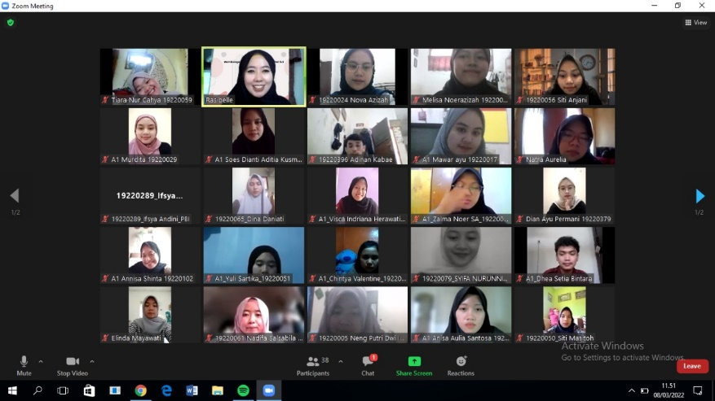
Picture 1. learning activity in English Entrepreneurship

The students appeared to have opened the camera in picture 1 above. It could be indicated that online learning was unaffected at that moment. There was no substantial downtime in the network. The students appeared to be passionate about paying attention to the researchers' entrepreneurial material. They appeared to be deeply moved by the information about using social media to boost sales.

Students’ Responses about The Tasks
The students performed a good job on the task, as shown in the Picture 2. They went to online class. They also snapped screenshots during lectures to demonstrate that they were here to learn about entrepreneurship. Within each assignment, there were several attachments. Even the students' grades could be described as perfect. It demonstrated that students wanted to put what they've learned into practice. Following the student interviews, they stated that the entrepreneurial material used during the COVID-19 epidemic was highly compelling. They became enlightened and began trading, among other things, via Whatsapp status updates.

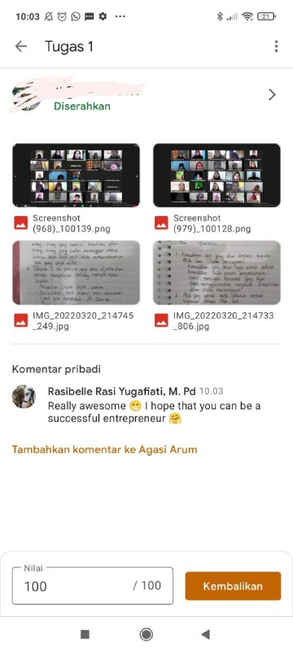
Figure 2. Students Tasks in English Entrepreneurship

Students’ Life Skill in Selling Products After Learning English Entrepreneurship

The students appeared to be starting to exhibit their selling statuses with captions that encourage the data base to shop in the Picture 3. Because when the “database” inquired about the displayed product, it indicated that they were around 30-40% interested. The students' tasks were to generate leads so that their sales could close. “Closing” are those that sell well in terms of online sales. Furthermore, following a series of contacts that build confidence, the data-driven were led to repeat orders.
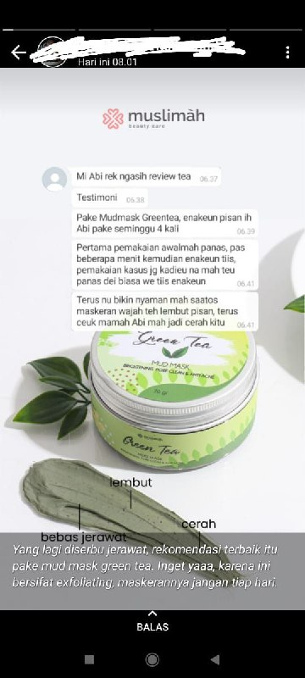

Figure 3. Student Caption on Whatsapp Status

Discussion

Based on the information presented above, it appeared that there were various topics to discuss. First, the students realized that the COVID-19 pandemic had caused in numerous changes in how they interacted. As social media became a more important aspect of people's personal and commercial life around the world, entrepreneurs should use various social networking sites to build ties with their existing and new customers (Turan & Kara, 2018). Individual boundaries could be pushed back. As a result, they could sell to a variety of groups as long as the information was recorded in their "database". Students could practice and demonstrate their English language skills while applying the content of their business and management classes to the tasks they had been given (Crompton & Head, 2003). Second, because social media might be reached through paid or organic channels, even lesser-known local brands could compete. As a result, students could use organic channels to promote their products and services. Understanding how social media works as a communication and marketing tool, as well as how they could use it to dramatically develop their enterprises, was crucial for business owners and marketers (Jagongo & Kinyua, 2013). Humane language could be used in caption processing to make it difficult for the database to refuse shopping. The students filled out the form based on the database's requirements.

CONCLUSION

The three research questions have been answered by this study. That students in the English language education department hopefully not only be capable in the field of teaching, but also possess the necessary survival skills. They are required to have a secondary source of income, rather than relying solely on their diplomas when applying for jobs. This entrepreneurship couse is designed to expand their thinking paradigm, allowing them to be more self-sufficient and capitalize on possibilities to increase turnover.

ACKNOWLEDGMENTS

Alhamdulillahirabbil’alamin. All glory to Allah SWT for allowing the researcher to complete this research. To all the lovely moments of life, joy and pride of knowledge, venture desiring, splendor of achievement, and all the wonderful and special experiences of the researcher's life, thanks to the kindly-hearted angels in IKIP Siliwangi.

REFERENCES

Ahmadinejad, B., & Asli, H. N. (2017). E-business through Social Media: A Quantitative Survey (Case Study: Instagram). https://www.ijmae.com/article_114926_554ecdd01bb4656071b6cf0daa211d1f.pdf, 80-99.
Alwasilah, A. (2018). Pokoknya Kualitatif: Dasar-dasar Merancang dan Melakukan Penelitian Kualitatif. Bandung: Pustaka Jaya.
Azhar, M., & Akhtar, M. J. (2020). SOCIAL MEDIA: A CATALYST FOR ENTREPRENEURSHIP AND MARKETING. South Asian Journal of Marketing & Management Research (SAJMMR)ISSN: 2249-877X Vol. 10, Issue 11, November 2020, Impact Factor: SJIF 2020= 7.11. https://www.researchgate.net/publication/347936299_Social_media_A_catalyst_for_entrepreneurship_and_marketing.
Crompton, P., & Head, M. (2003). Fostering entrepreneurs in a Business English course. Journal of Language for International Business, 14 (2), https://www.researchgate.net/publication/271325047_Fostering_entrepreneurs_in_a_Business_English_course/link/54c4e13d0cf219bbe4f00522/download, 11-24.
Dinçay, T. (2011). Advantages of learning A foreign language at an early age, Zaman Newspaper. . http://www.todayszaman.com/oped_advantages-of-learning-a-foreign-language-at-an-early-age_263877.html.
Drucker, P. F. (1984). Innovation and entrepreneurship: Practices and Principles. Claremont, California: perfectbound.
Jagongo, A., & Kinyua, C. (2013). The Social Media and Entrepreneurship Growth (A New Business Communication Paradigm among SMEs in Nairobi). International Journal of Humanities and Social Science Vol. 3 No. 10 [Special Issue – May 2013] http://ijhssnet.com/journals/Vol_3_No_10_Special_Issue_May_2013/24.pdf, 213-227.
Lackéus, M. (2015). Entrepreneurship in Education: What, Why, When, How. France: OECD.
Özdemir, P. (2015). A combined approach to teaching English and entrepreneurship. Procedia - Social and Behavioral Sciences 199 . https://www.researchgate.net/publication/283165689_A_Combined_Approach_to_Teaching_English_and_Entrepreneurship, 293 – 297 .
Pakura, S., & Rudeloff, C. (2020). How entrepreneurs build brands and reputation with social media PR: empirical insights from start-ups in Germany. Journal of Small Business & Entrepreneurship. https://www.tandfonline.com/doi/full/10.1080/08276331.2020.1728490, 1-28.
Sajane, S., & Gaikwad, H. (2022). RESEARCH ON THE IMPACT OF SOCIAL MEDIA ON BUSINESS/STARTUPS. Indonesian Journal of Entrepreneurship& Technopreneur 1 https://ojs.unikom.ac.id/index.php/injetech/article/view/6088, 13-22.
Silverman, D. (2015). Doing Qualitative Research : A Practical Handbook (Second). . London: Sage Publications. Ltd.
Simangunsong, E., & Handoko, R. (2020). The Role of Social Media in Indonesia for Business Transformation Strategy. International Research Journal of Business Studies | vol. XIII no. 01 (April - July 2020) http://www.irjbs.com/index.php/jurnalirjbs/article/view/1570, 99-112.
Tosifyan, M., & Tosifyan, S. ( 2017). A Research on the Effect of Social Media on Tendency to Entrepreneurship and Business Establishment (Case Study: Active Iranian Entrepreneurs in Social Media). Italian Journal of Science & Engineering Vol. 1, No. 1, June, 2017 https://www.ijournalse.org/index.php/ESJ/article/view/20, 43-48.
Turan, M., & Kara, A. (2018). Online social media usage behavior of entrepreneurs in an emerging market: Reasons, expected benefits and intentions. Journal of Research in Marketing and Entrepreneurship, https://www.researchgate.net/publication/328023497_Online_social_media_usage_behavior_of_entrepreneurs_in_an_emerging_market_Reasons_expected_benefits_and_intentions.
Wardana, L. W. (2018). THE ROLE OF FACEBOOK AS A SOCIAL MEDIA MARKETING ON HOUSEWIVES’ START-UP BUSINESS. Journal of Entrepreneur and Entrepreneurship, Vol. 7, No. 2, September 2018, 79–86ISSN 2302-1802 print / ISSN 2580-9393 https://journal.uc.ac.id/index.php/JEE/article/view/1107, 79–86.

