Appendix 1
Population Profile

Student (Code) | IPK/Indeks Prestasi Komulatif | Absence | Short Story Grade | Number of Words of the narrative
A | 3.92 | 0 | 92.4 | 2569
B | 3.82 | 0 | 89.6 | 1460
C | 3.82 | 0 | 88.8 | 1888
D | 3.66 | 0 | 88.0 | 1006
E | 3.63 | 0 | 83.6 | 928
F | 3.62 | 0 | 80.8 | 2017
G | 3.34 | 0 | 75.4 | 4730
H | 3.12 | 0 | 75.0 | 758
I | 3.07 | 0 | 73.4 | 1706
J | 2.86 | 0 | 83.0 | 1546

Appendix 2
Curriculum Data
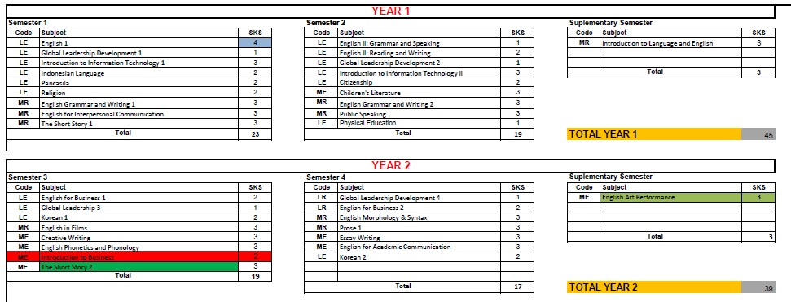

Appendix 3
Error Spot Checklist
Error Spot Checklist (Student B)
Sentences | Types of Errors |  |  |  | Errors | Corrections | Theory
 | O | A | M | Mi
1 |  |  |  | ✓ | Though they are poor, they had enough food that they found in the wood. | Though they were poor, they had enough food that they found in the wood. | Herring (2016) “ the past progressive, the past continuous tense is used to describe something that was in progress at a certain moment in the past. It is called the past continuous because it uses the past tense of the auxiliary verb be (was or were)
2 | ✓ |  |  |  | The father worked as a wood-cutter and the mom just stay at home to cook and look for their child, Naja | The father worked as a wood-cutter and the mom just stayed at home to cook and look for their child, Naja | Herring (2016) “ The simple past tense is used to express completed actions. It is known as the past simple because it does not require any auxiliary verbs to complete its meaning; its structure is simply the past-tense form of the verb.”
3 |  |  |  | ✓ | She’s small and had big eyes. | She was small and had big eyes. | Herring (2016) “ the past progressive, the past continuous tense is used to describe something that was in progress at a certain moment in the past. It is called the past continuous because it uses the past tense of the auxiliary verb be (was or were)
4 |  |  |  | ✓  ✓ | She grew well and became a brave, with golden heart which makes her like to help people. | She grew well and became a brave, with golden heart which made her liked to help people. | Herring (2016) “ The simple past tense is used to express completed actions. It is known as the past simple because it does not require any auxiliary verbs to complete its meaning; its structure is simply the past-tense form of the verb.”
5 |  |  |  | ✓ | Her bicycle is too old for her | Her bicycle was too old for her | Herring (2016) “ the past progressive, the past continuous tense is used to describe something that was in progress at a certain moment in the past. It is called the past continuous because it uses the past tense of the auxiliary verb be (was or were)
6 |  |  |  | ✓ | She tried to beg to her parents to buy the new one for her, but nothing they can do according to their financial condition | She tried to beg to her parents to buy the new one for her, but nothing they could do according to their financial condition | Herring (2016) “ The modal verb could is most often used as a past-tense version of the can, indicating what someone or something was able to do in the past.”
7 | ✓ |  |  |  | There Naja and her old bicycle going nowhere | There Naja and her old bicycle were going nowhere | Herring (2016) “ the past progressive, the past continuous tense is used to describe something that was in progress at a certain moment in the past. It is called the past continuous because it uses the past tense of the auxiliary verb be (was or were)
8 |  |  |  | ✓  ✓ | Naja knows that old woman needs a food to eat, she looks almost like a skeleton | Naja knew that old woman needs a food to eat, she looked almost like a skeleton | Herring (2016) “ The simple past tense is used to express completed actions. It is known as the past simple because it does not require any auxiliary verbs to complete its meaning; its structure is simply the past-tense form of the verb.”
9 |  |  |  | ✓  ✓  ✓ | Naja feel relaxed that she could help the old woman out of her hunger. So then, Naja get on her bike. and get ready to go | Naja felt relaxed that she could help the old woman out of her hunger. So then, Naja got on her bike and got ready to go | Herring (2016) “ The simple past tense is used to express completed actions. It is known as the past simple because it does not require any auxiliary verbs to complete its meaning; its structure is simply the past-tense form of the verb.”
10 | ✓  ✓ |  |  |  | On the way, she kept think about the thing the old woman gave to her | On the way, she had kept thinking about the thing the old woman gave to her | Herring (2016) “The past perfect tense expresses the idea that something occurred before another action in the past. To form the past perfect, we use had (the past tense of the auxiliary verb have) + the past participle of the main verb.”
11 |  |  |  | ✓ | She stopped at a bus stop and sit there looking at the thing she received from the old woman. | She stopped at a bus stop and sat there looking at the thing she received from the old woman. | Herring (2016) “Irregular verbs have past tense and past participle forms that do not adhere to a distinct or predictable pattern, and they are usually completely different from one another.”
12 |  | ✓ |  | ✓ | Naja was get more shock that the monster is able to talk too | Naja got more shock that the monster was able to talk too | Herring (2016) “Irregular verbs have past tense and past participle forms that do not adhere to a distinct or predictable pattern, and they are usually completely different from one another.”  Herring (2016) “ the past progressive, the past continuous tense is used to describe something that was in progress at a certain moment in the past. It is called the past continuous because it uses the past tense of the auxiliary verb be (was or were)
13 |  |  |  | ✓ | She gets closer to the little monster and started to touch the monster’s soft fur | She got closer to the little monster and started to touch the monster’s soft fur | Herring (2016) “Irregular verbs have past tense and past participle forms that do not adhere to a distinct or predictable pattern, and they are usually completely different from one another.”
14 | ✓ |  |  |  | All of sudden, her stomach making some weird sound again | All of sudden, her stomach was making some weird sound again | Herring (2016) “ the past progressive, the past continuous tense is used to describe something that was in progress at a certain moment in the past. It is called the past continuous because it uses the past tense of the auxiliary verb be (was or were)
15 | ✓ |  |  | ✓ | But then, she’s confused that the monster gone and nowhere to be found | But then, she was confused that the monster had gone and nowhere to be found | Herring (2016) “the past progressive, the past continuous tense is used to describe something that was in progress at a certain moment in the past. It is called the past continuous because it uses the past tense of the auxiliary verb be (was or were)  Herring (2016) “The past perfect tense expresses the idea that something occurred before another action in the past. To form the past perfect, we use had (the past tense of the auxiliary verb have) + the past participle of the main verb.”
16 |  |  |  | ✓ | She realized that if she chews the gum, the monster would appear again | She realized that if she chewed the gum, the monster would appear again | Herring (2016) “Regular verbs, which means that “-d” or “-ed” can be added to their base form (the infinitive of the verb without to) to conjugate both the simple past tense and past participle forms.”
17 |  |  |  | ✓ | Naja feel so sad and angry at the same time | Naja felt so sad and angry at the same time | Herring (2016) “Irregular verbs have past tense and past participle forms that do not adhere to a distinct or predictable pattern, and they are usually completely different from one another.”
18 |  |  |  | ✓  ✓  ✓ | She got an idea to call the monster out again. She takes the gum, eat and chew it | She got an idea to call the monster out again. She took the gum, ate, and chewed it | Herring (2016) “Irregular verbs have past tense and past participle forms that do not adhere to a distinct or predictable pattern, and they are usually completely different from one another.”  Herring (2016) “Regular verbs, which means that “-d” or “-ed” can be added to their base form (the infinitive of the verb without to) to conjugate both the simple past tense and past participle forms.”
19 |  |  |  | ✓ | She didn’t listen to the monster and go to the closest department store | She didn’t listen to the monster and went to the closest department store | Herring (2016) “Irregular verbs have past tense and past participle forms that do not adhere to a distinct or predictable pattern, and they are usually completely different from one another.”
20 |  |  |  | ✓ | Less than 3 minutes she drives the car | Less than 3 minutes she drove the car | Herring (2016) “Irregular verbs have past tense and past participle forms that do not adhere to a distinct or predictable pattern, and they are usually completely different from one another.”
21 |  |  |  | ✓ | She broke so many things and have to pay for that | She broke so many things and had to pay for that | Herring (2016) “Irregular verbs have past tense and past participle forms that do not adhere to a distinct or predictable pattern, and they are usually completely different from one another.”
22 | ✓ |  |  |  | You supposed to listen to what the grandma said to you | You were supposed to listen to what the grandma said to you | Herring (2016) “ the past progressive, the past continuous tense is used to describe something that was in progress at a certain moment in the past. It is called the past continuous because it uses the past tense of the auxiliary verb be (was or were)
23 | ✓ |  |  |  | She cried a lot and regret what she has done | She cried a lot and regretted what she has done | Herring (2016) “Regular verbs, which means that “-d” or “-ed” can be added to their base form (the infinitive of the verb without to) to conjugate both the simple past tense and past participle forms.”
24 | ✓  ✓ |  |  |  | Naja surprised and quickly chew the gum and when the monster appeared | Naja was surprised and quickly chewed the gum and when the monster appeared | Herring (2016) “ the past progressive, the past continuous tense is used to describe something that was in progress at a certain moment in the past. It is called the past continuous because it uses the past tense of the auxiliary verb be (was or were)  Herring (2016) “Regular verbs, which means that “-d” or “-ed” can be added to their base form (the infinitive of the verb without to) to conjugate both the simple past tense and past participle forms.”
25 |  |  |  | ✓ | A strong light made she closed her eyes and suddenly she’s at her room at home | A strong light made she closed her eyes and suddenly she was at her room at home | Herring (2016) “ the past progressive, the past continuous tense is used to describe something that was in progress at a certain moment in the past. It is called the past continuous because it uses the past tense of the auxiliary verb be (was or were)
Frequency | 10 | 1 | 0 | 24

Notes: O = Omission, A=Addition, M=Misordering, Mi= Misformation
Error Spot Checklist (Student F)
Sentences | Types of Errors |  |  |  | Errors | Corrections | Theory
 | O | A | M | Mi
1 |  |  |  | ✓ | They are the Mirabeth family | They were the Mirabeth family | Herring (2016) “ the past progressive, the past continuous tense is used to describe something that was in progress at a certain moment in the past. It is called the past continuous because it uses the past tense of the auxiliary verb be (was or were)
2 |  |  |  | ✓  ✓ | Maribeth is a young woman who lives with her father and mother in a small house | Maribeth was a young woman who lived with her father and mother in a small house | Herring (2016) “ the past progressive, the past continuous tense is used to describe something that was in progress at a certain moment in the past. It is called the past continuous because it uses the past tense of the auxiliary verb be (was or were)  Herring (2016) “Regular verbs, which means that “-d” or “-ed” can be added to their base form (the infinitive of the verb without to) to conjugate both the simple past tense and past participle forms.”
3 |  |  |  | ✓  ✓ | They are very poor family, but they are very happy | They were a very poor family, but they were very happy | Herring (2016) “ the past progressive, the past continuous tense is used to describe something that was in progress at a certain moment in the past. It is called the past continuous because it uses the past tense of the auxiliary verb be (was or were)
4 |  |  |  | ✓ | Waves that are so large make the ship unstable | Waves that were so large make the ship unstable | Herring (2016) “the past progressive, the past continuous tense is used to describe something that was in progress at a certain moment in the past. It is called the past continuous because it uses the past tense of the auxiliary verb be (was or were)
5 |  |  |  | ✓ | Their lives are getting poorer | Their lives were getting poorer | Herring (2016) “ the past progressive, the past continuous tense is used to describe something that was in progress at a certain moment in the past. It is called the past continuous because it uses the past tense of the auxiliary verb be (was or were)
6 |  |  |  | ✓ | The mother and Mirabeth tried to sell their vegetables so they can buy medicine for the father | The mother and Mirabeth tried to sell their vegetables so they could buy medicine for the father | Herring (2016) “ The modal verb could is most often used as a past-tense version of the can, indicating what someone or something was able to do in the past.”
7 |  |  |  | ✓ | The vegetables they sell didn't sell well every day, sometimes they work in the fields of the richest people in the village so they can get extra money | The vegetables they sell didn't sell well every day, sometimes they work in the fields of the richest people in the village so they could get extra money | Herring (2016) “ The modal verb could is most often used as a past-tense version of the can, indicating what someone or something was able to do in the past.”
8 |  |  |  | ✓ | They are very sad because the ocean does not produce fish anymore | They were very sad because the ocean did not produce fish anymore | Herring (2016) “the past progressive, the past continuous tense is used to describe something that was in progress at a certain moment in the past. It is called the past continuous because it uses the past tense of the auxiliary verb be (was or were)  Herring (2016) “Negative sentences in simple past tense tell the reader what did not happen. To form negative sentences in the simple past tense, we must use the auxiliary verb did (the past tense of do).”
9 |  |  |  | ✓ | The fish has been fried, Mother, there's nothing else that Mirabeth can do | The fish has been fried, Mother, there's nothing else that Mirabeth could do | Herring (2016) “ The modal verb could is most often used as a past-tense version of the can, indicating what someone or something was able to do in the past.”
10 | ✓ |  |  | ✓  ✓  ✓ | Their rush does not produce any results. Many fish are still left on the plate when dad comes home | Their rush did not produce any results. Many fish were still left on the plate when dad had come home | Herring (2016) “Negative sentences in simple past tense tell the reader what did not happen. To form negative sentences in the simple past tense, we must use the auxiliary verb did (the past tense of do).”  Herring (2016) “ the past progressive, the past continuous tense is used to describe something that was in progress at a certain moment in the past. It is called the past continuous because it uses the past tense of the auxiliary verb be (was or were)”  Herring (2016) “The past perfect tense expresses the idea that something occurred before another action in the past. To form the past perfect, we use had (the past tense of the auxiliary verb have) + the past participle of the main verb.”
11 |  |  |  | ✓ | Father clenches his fist and hits Mirabeth and mother | Father clenched his fist and hits Mirabeth and mother | Herring (2016) “Regular verbs, which means that “-d” or “-ed” can be added to their base form (the infinitive of the verb without to) to conjugate both the simple past tense and past participle forms.”
12 | ✓ |  |  | ✓ | She is been there for a half day, but she did not get any fish | She had been there for a half day, but she did not get any fish | Herring (2016) “The past perfect continuous tense is used to describe an action that began and was still in progress in the past before another past action started. To form the past perfect continuous, we use had been + the present participle of the main verb.”
13 | ✓ |  |  | ✓ | Their routine activities going well, they feel happy and peaceful | Their routine activities were going well, they felt happy and peaceful | Herring (2016) “ the past progressive, the past continuous tense is used to describe something that was in progress at a certain moment in the past. It is called the past continuous because it uses the past tense of the auxiliary verb be (was or were).”  Herring (2016) “Irregular verbs have past tense and past participle forms that do not adhere to a distinct or predictable pattern, and they are usually completely different from one another.”
14 |  |  |  | ✓ | One day tornadoes drowned the father’s boat and he fall down to the sea | One day tornadoes drowned the father’s boat and he fell down to the sea | Herring (2016) “Irregular verbs have past tense and past participle forms that do not adhere to a distinct or predictable pattern, and they are usually completely different from one another.”
15 |  |  |  | ✓ | The father shock when he saw the mermaid, he was thought that the mermaid made his boat sink, but is not actually done by the mermaid | The father shock when he saw the mermaid, he was thought that the mermaid made his boat sink, but was not actually done by the mermaid | Herring (2016) “ the past progressive, the past continuous tense is used to describe something that was in progress at a certain moment in the past. It is called the past continuous because it uses the past tense of the auxiliary verb be (was or were).”
16 |  |  |  | ✓ | From that very day the father was sick and he cannot go anywhere | From that very day the father was sick and he could not go anywhere | Herring (2016) “ The modal verb could is most often used as a past-tense version of the can, indicating what someone or something was able to do in the past.”
17 |  |  |  | ✓ | Maribeth who usually make a cup of coffee for the father, now on they had nothing | Maribeth who usually made a cup of coffee for the father, now on they had nothing | Herring (2016) “Irregular verbs have past tense and past participle forms that do not adhere to a distinct or predictable pattern, and they are usually completely different from one another.”
18 | ✓ | ✓ |  | ✓ | After they finisher worship God the mother persuade the father to agree with her about cooked the golden fish for their lunch, Mirabeth did not know about this | After they finished worship God the mother persuaded the father to agree with her about cooked the golden fish for their lunch; Mirabeth did not know about this | Herring (2016) “Nouns that are, were, or can be distinguished between feminine and masculine genders are often masculine in their basic form. These tend to end in “-er” or “-or” to denote someone who performs the action of a verb.”  Herring (2016) “Regular verbs, which means that “-d” or “-ed” can be added to their base form (the infinitive of the verb without to) to conjugate both the simple past tense and past participle forms.”
19 |  |  |  | ✓ | “Happy birthday to you” the father and the mother sing together even though the father cannot sing well | “Happy birthday to you” the father and the mother sing together even though the father could sing well | Herring (2016) “ The modal verb could is most often used as a past-tense version of the can, indicating what someone or something was able to do in the past.”
20 |  |  |  | ✓  ✓ | Maribeth afraid that she will become a mermaid, the parents did not know when the golden fish died she will become a mermaid | Maribeth afraid that she would become a mermaid, the parents did not know when the golden fish died she would become a mermaid | Herring (2016) “The modal auxiliary verb would have a variety of functions and uses. It is used in place of will for things that happened or began in the past.”
21 |  |  |  | ✓ | They cannot life together | They couldn’t life together | Herring (2016) “ The modal verb could is most often used as a past-tense version of the can, indicating what someone or something was able to do in the past.”
22 | ✓ |  |  | ✓ | It been five years since Mirabeth being a mermaid, the mother always went to the sea and shut her name, but Mirabeth cannot hear them | It had been five years since Mirabeth being a mermaid, the mother always went to the sea and shut her name, but Mirabeth couldn’t hear them | Herring (2016) “The past perfect tense expresses the idea that something occurred before another action in the past. To form the past perfect, we use had (the past tense of the auxiliary verb have) + the past participle of the main verb.”  Herring (2016) “ The modal verb could is most often used as a past-tense version of the can, indicating what someone or something was able to do in the past.”
23 |  |  |  | ✓ | The father felt tired with all, he cannot meet Mirabeth, and his condition also very week | The father felt tired with all, he could meet Mirabeth, and his condition also very week | Herring (2016) “ The modal verb could is most often used as a past-tense version of the can, indicating what someone or something was able to do in the past.”
24 | ✓ |  |  | ✓ | Until the right time coming, she is been living in the sea for ten years and she finally go back to the land | Until the right time coming, she had been living in the sea for ten years and she finally went back to the land | Herring (2016) “The past perfect tense expresses the idea that something occurred before another action in the past. To form the past perfect, we use had (the past tense of the auxiliary verb have) + the past participle of the main verb.”  Herring (2016) “Irregular verbs have past tense and past participle forms that do not adhere to a distinct or predictable pattern, and they are usually completely different from one another.”
25 | ✓ |  |  |  | But finally she arrive home safety | But finally, she arrived home safety | Herring (2016) “Regular verbs, which means that “-d” or “-ed” can be added to their base form (the infinitive of the verb without to) to conjugate both the simple past tense and past participle forms.”
26 |  |  |  | ✓ | “Your father killed himself in the room by the rope. He felt really pale and sick, I don’t know why he did it” | “Your father killed himself in the room by the rope. He felt really pale and sick, I did not know why he did it” | Herring (2016) “Negative sentences in simple past tense tell the reader what did not happen. To form negative sentences in the simple past tense, we must use the auxiliary verb did (the past tense of do) together with not before the main verb of the sentence.”
27 |  |  |  | ✓ | “Maribeth I did not having a food for a week, I'm sick and I’m weak. I hope you can have a long life and safety” | “Maribeth, I did not have a food for a week, I'm sick and I’m weak. I hope you can have a long life and safety” | Herring (2016) “Negative sentences in simple past tense tell the reader what did not happen. To form negative sentences in the simple past tense, we must use the auxiliary verb did (the past tense of do) together with not before the main verb of the sentence.”
Frequency | 7 | 1 | 0 | 31

Notes: O = Omission, A=Addition, M=Misordering, Mi= Misformation

Error Spot Checklist (Student J)
Sentences | Types of Errors |  |  |  | Errors | Corrections | Theory
 | O | A | M | Mi
1 | ✓ |  |  | ✓ | "Pardon me Mam, if you feel I am wrong. I just wanted to ask that do you really feel true friendship exists? Did you ever see a never ending bond between friends?" | "Pardon me Mam, if you feel I am wrong. I just wanted to ask that do you really feel true friendship exists? had you ever seen a never-ending bond between friends?" | Herring (2016) “To form interrogative sentences in the past perfect, the auxiliary verb had again comes before the subject, which is then followed by the past participle of the main verb. Most of the time, we use the word ever before the main verb to ask if something had happened or been the case at any time before something else.”
2 | ✓ |  |  |  | One day, a family moved to the town | One day, a family had moved to the town | Herring (2016) “The past perfect tense expresses the idea that something occurred before another action in the past. It can also show that something happened before a specific time in the past.”
3 | ✓ |  |  |  | John was so spellbound by his answer and the pleasant request, that he opened his box and handed it over to him | John was so spellbound by his answer and the pleasant requested, that he opened his box and handed it over to him | Herring (2016) “Regular verbs, which means that “-d” or “-ed” can be added to their base form (the infinitive of the verb without to) to conjugate both the simple past tense and past participle forms.”
4 |  |  | ✓ |  | But he was again taken by shock when Martin went to the teacher to ask for glue tape to join the page. | But he was taken again by shock when Martin went to the teacher to ask for glue tape to join the page. | Herring (2016) “Adverbs of time are most often placed at the end of a sentence. However, we can sometimes place adverbs of time at the beginning of the sentence to put an extra emphasis on the time or duration being described. They are usually offset by a comma if appearing at the beginning of the sentence.”
5 |  |  |  | ✓ | Martin smiled and then turning towards John, he said, "I do not fight my friends | Martin smiled and then turned towards John. He said, "I do not fight my friends | Herring (2016) “Regular verbs, which means that “-d” or “-ed” can be added to their base form (the infinitive of the verb without to) to conjugate both the simple past tense and past participle forms.”
6 | ✓ |  |  |  | Martin’s words worked wonders on John; he sat there staring quietly at Martin | Martin’s words worked wonders on John; he sat there while staring quietly at Martin | Herring (2016) states that while is one of the subordinating conjunctions that is being used when two activities happen simultaneously.
7 | ✓ |  |  |  | "It’s my turn to ask question. Tell me John why you go around spoiling others' things. Instead of making friends you turn them into enemies. What drives you to do all these?" | "It’s my turn to ask question. Tell me, John, why you go around spoiling others' things. Instead of making friends, you turn them into enemies. What did drive you to do all these?" | Herring (2016) states that in question word of simple paste tense, we can use who/whom, what, where, etc., before did (aux) and add a verb, which is a causative verb.
8 | ✓ |  |  |  | he said, "My parents never paid any attention to me[...]” | he said, "My parents had never paid any attention to me[...]” | Herring (2016) “The past perfect tense expresses the idea that something occurred before another action in the past. To form the past perfect, we use had (the past tense of the auxiliary verb have) + the past participle of the main verb.”
9 | ✓ |  |  |  | “They never greeted me either in the morning or at night.” | They had never greeted me either in the morning or at night | Herring (2016) “The past perfect tense expresses the idea that something occurred before another action in the past. To form the past perfect, we use had (the past tense of the auxiliary verb have) + the past participle of the main verb.”
10 |  |  |  | ✓ | “I thought that if I do some mischief, I would get the time to be around my parents.” | “I thought that if I did some mischief, I would get the time to be around my parents.” | Herring (2016) “Second conditional is to speak about a hypothetical situation or outcome resulting from the condition. We use the second conditional to talk about things that cannot or are unlikely to happen. To create the second conditional, we use the simple past tense after the if clause, followed by would + the bare infinitive for the result of the condition.”
11 | ✓ |  |  | ✓ | “He came to me to thank me for making him sit beside Martin.” | “He came to me to thank me for making him had sat beside Martin.” | Herring (2016) “The past perfect tense expresses the idea that something occurred before another action in the past. To form the past perfect, we use had (the past tense of the auxiliary verb have) + the past participle of the main verb.”
12 |  |  |  | ✓ | After maximum of the students were pulled out of the school, some of us ran throughout the building to ensure that no one else is left in the school building | After the maximum of the students were pulled out of the school, some of us ran throughout the building to ensure that no one else was left in the school building | Herring (2016) “ the past progressive, the past continuous tense is used to describe something that was in progress at a certain moment in the past. It is called the past continuous because it uses the past tense of the auxiliary verb be (was or were).”
13 | ✓ |  |  |  | When I reached the third floor, I saw John, lying on his chest, supporting himself with the help of pillar and stretching his hand out as if trying to pull some one up | When I had reached the third floor, I saw John, lying on his chest, supporting himself with the help of a pillar and stretching his hand out as if trying to pull someone up | Herring (2016) “The past perfect tense expresses the idea that something occurred before another action in the past. To form the past perfect, we use had (the past tense of the auxiliary verb have) + the past participle of the main verb.”
14 | ✓ |  |  |  | Moreover you promise me to be with me throughout my life | Moreover, you promised to me to be with me throughout my life | Herring (2016) “Regular verbs, which means that “-d” or “-ed” can be added to their base form (the infinitive of the verb without to) to conjugate both the simple past tense and past participle forms.”
15 | ✓ |  |  |  | We were on our way and just reached the other end of third floor, from where we could see John lying on the ground | We were on our way and just reached the other end of the third floor, from where we could see John was lying on the ground | Herring (2016) “ the past progressive, the past continuous tense is used to describe something that was in progress at a certain moment in the past. It is called the past continuous because it uses the past tense of the auxiliary verb be (was or were).”
Frequency | 11 | 0 | 1 | 5

Notes: O = Omission, A=Addition, M=Misordering, Mi= Misformation

Appendix 4
Students’ Narrative Texts (Student B)
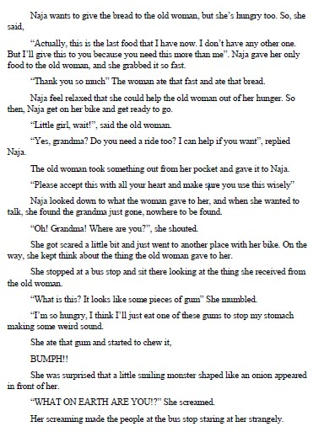
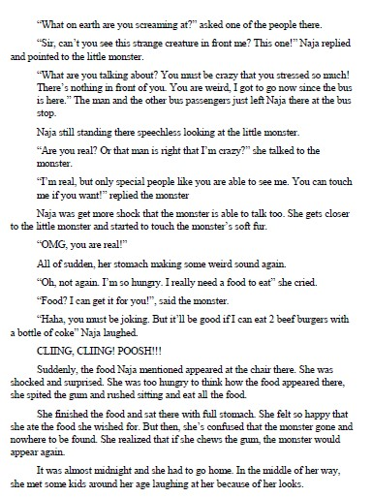

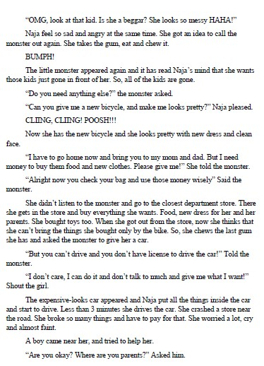
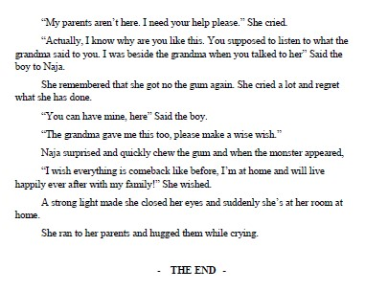

Students’ Narrative Texts (Student F)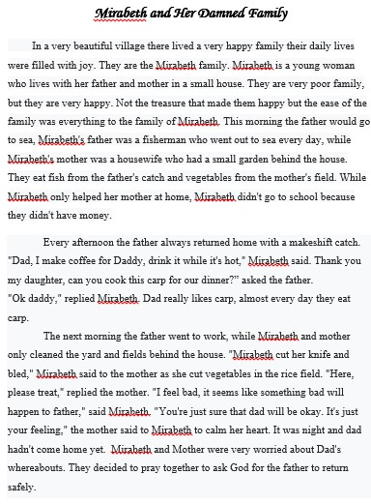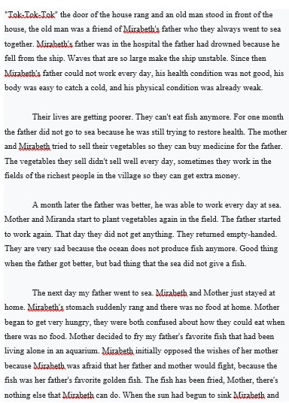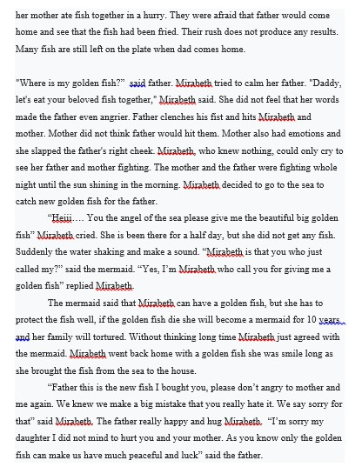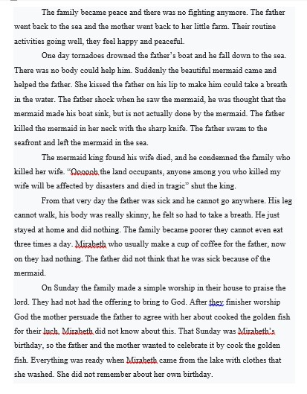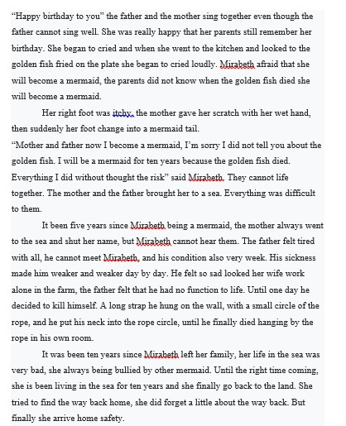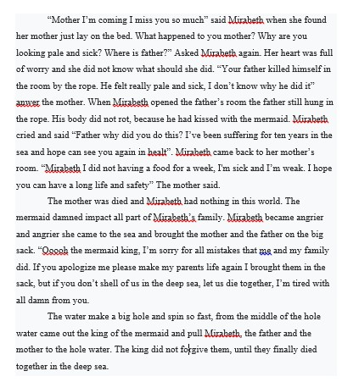

Students’ Narrative Texts (Student J)